China Water Risk
June 14, 2018

2017 State Of Ecology & Environment Report Review
China Water Risk
We find mixed trends for China's water in 2017
Highlights
- Prioritising rivers pays off as main river basins' overall quality improved; but 5 Northern rivers below 70% target
- Overall groundwater quality continues to worsen despite 2016 bleep; Key Lakes & Reservoirs also deteriorate
- Maybe like the revision of over-inflated GDP figures this year, we are now seeing the “real” state of environment
On 31 May, 2018, the new Ministry of Ecology and Environment (MEE) released the 2017 State of Ecology and Environment Report (SOEE), formerly the “State of Environment Report” (SOE).
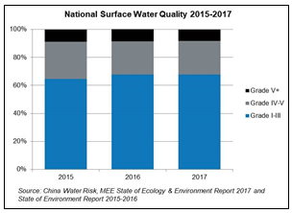

The report cites 2017 as “a crucial year for China in implementing the 13FYP for Ecological & Environmental Protection”, reporting that “‘good quality’ surface water has continuously improved nationally”.
Indeed, it shows Grade I-III national surface water rising to 67.9% and Grade V+ dropping to 8.3%. As seen from the right chart, it is a marked improvement from 2015 when China first started disclosing it.
This is a clearly a positive trend. Surface water improvement is also reflected in an improvement in the overall surface water quality of China’s rivers as well as the overall quality of the river basins’ shallow groundwater as can be seen from the charts below:
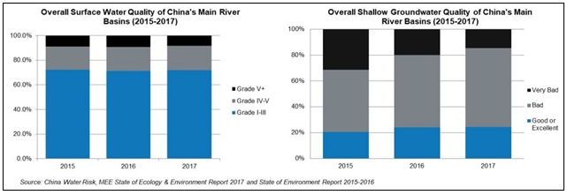
However, it’s not all positive. A closer look shows that the overall quality of Key Lakes & Reservoirs as well as groundwater has deteriorated. The key results from the 2017 report are as follows:
- Main Rivers – overall surface quality of China main river basins meeting Grade I-III rises slightly to 71.8%, meeting the Water Ten target of 70%, but 5 Northern rivers still fail to meet the target;
- Key Lakes & Reservoirs – deteriorates across all categories since 2015, almost giving up previous gains;
- Groundwater – unlike improvement in shallow groundwater, overall groundwater quality continues to deteriorate despite improvement in 2016; and
- Monitoring coverage – this has generally increased over the last 5 years but groundwater monitoring stations dropped 17% in the last year to 5,100. Note that such fluctuations in stations over the years mean that historic data is not exactly comparable and should be taken as indicative trends. This also applies to other water bodies
Prioritising rivers appears to have paid off
It is not surprising that rivers are doing better; they have been the government’s focus in recent years. In 2016, China more than doubled the river surface monitoring stations to 1,617 and in 2017 plus river chiefs were introduced as part of the war on pollution. Clearer divisions of responsibility and better coordination among the river chiefs, as well as increased public monitoring appear to be working.
Enforcement has also stepped up. According to the report, the number of environmental violations has increased in the past year:
- A total of RMB11.6bn in environmental violation fines were handed out; according to the MEE, this was a 265% increase over 2014 before the revised Environmental Protection Law was in effect;
- Total administrative penalties against violations have risen by almost 180% since 2014, from 83,195 to 233,000; and
- Environmental complain hotline “12369” received a total of 618,856 public complaints, with almost all of them handled (99.9%)
Although this was not mentioned the 2017 SOEE report, it is worth noting that the total cases of seizures, administrative detention, criminal charges, production halts and daily fines also increased 74% from 22,730 in 2016 to 39,600 in 2017.

A more realistic view of groundwater and Key Lakes & Reservoirs?
Although the report provides no explanation of the recent deterioration in groundwater or Key Lakes & Reservoirs, we did say in “5 Trends for the Year of the Dog” that “as watchdogs become more powerful, environmental disclosure will be on the rise and become increasingly accurate.” Perhaps similar to the revision of fake and over-inflated GDP figures across various cities, counties and provinces earlier this year, the latest MEE numbers may well reflect the “real” state of environment.
Nevertheless, looking forward, we expect to see not only improvement in surface water quality, but other water bodies too (albeit slower for groundwater as this is harder to tackle). This is because the Water Ten Law is now effective as of 1 January 2018. Moreover, more than 900,000 river chiefs are appointed as of December 2017; this is more than quadruple the 200,000 as of August 2017. There is also a new environmental tax law and water resource tax expansion – read more on these here.
We can also expect the newly established MEE to show “more teeth” and take on more responsibility in implementing holistic action to protect the environment. That said, we clearly have far to go on all fronts. Below are detailed accounts of the 2017 SOEE report …

Key Lakes & Reservoirs – water quality deteriorating across all categories
Water quality of China’s Key Lakes and Reservoirs improved considerably during 2011-2015, but then declined. The share of Key Lakes & Reservoirs with Grade I-III declined from 66% in 2016 to 62.5% in 2017. Moreover, the proportion of water bodies that are “unfit for human contact” (Grade IV-V+) worsened from 34% to 37.4%.
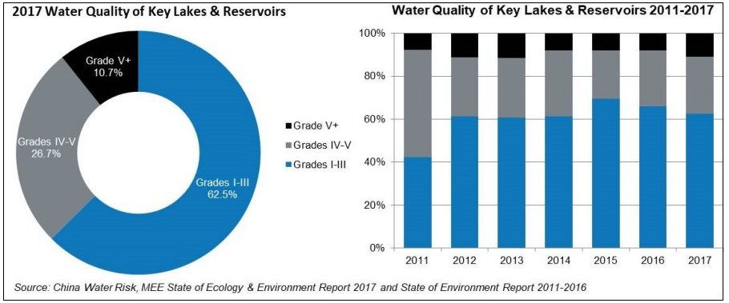

Shallow groundwater of China’s river basins – overall quality continues to improve, but mixed performances in individual river basins…
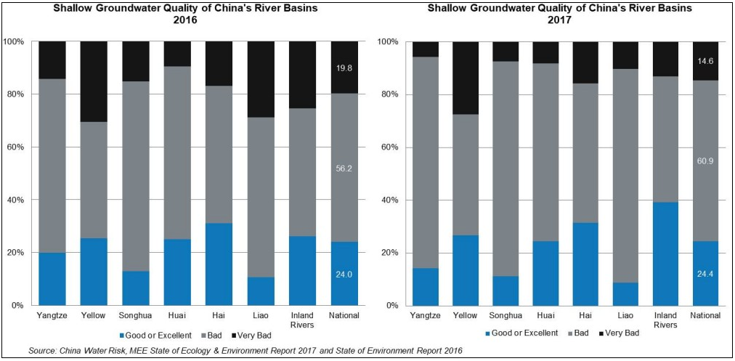
Meanwhile, on a more positive note, the overall shallow groundwater quality of China’s main river basins has shown continuous improvement as discussed previously. However, individually, they indicate mixed performance. The charts above show the breakdown of the differences in water quality across the main river basins disclosed in the SOE/SOEE report between 2016 and 2017.
As per charts above, 4 river basins show a decline in “good or excellent” shallow groundwater quality from previous years: Yangtze (-5,7%), Liao (-1.8%), Songhua (-1.7%), and Huai (-0.7%). On the other hand, Inland Rivers shows a material improvement in the proportion of “good or excellent” quality by 13%, which topped other river basins at 39.1%. Following this, Yellow and Hai show a +1.3% and +0.3 improvement in the same category respectively.
Despite the mixed performance in “good or excellent” category across the main river basins, all of them have improved in the “very bad” category. Liao shows the highest improvement in the proportion of “very bad” quality by 18.6%, followed by Inland Rivers (12.4%), Yangtze (8.6%), Songhua (7.7%), Yellow (3%), Huai (1.3%) and Hai (1.2%).

Overall river quality – improving but 5 Northern Rivers continue to struggle to meet Water Ten target…
As discussed previously, the overall quality of China’s main river basins has gradually improved from 2015 to 2017. General improvements can be identified between 2016 and 2017 across all categories except for Grade IV-V: Grade I-III water improved from 71.2% to 71.8; Grade IV-V deteriorated from 19.7% to 19.8%; and Grade V+ improved from 9.1% to 8.4%.
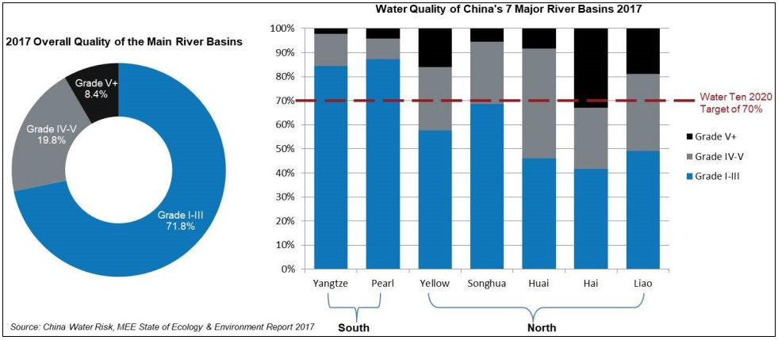
However, similar to shallow groundwater, there are also mixed performances in individual water quality of China’s 7 major river basins. While Southern rivers (Yangtze and Pearl) are doing relatively well, Northern Rivers continue to struggle in reaching the Water Ten target of 70% surface water meeting Grade III or better by 2020. Note above that Songhua has nearly reached the Water Ten target. Can it be the first Northern River to meet the Water Ten target?

Breakdown of 7 major river basins – overall surface quality improved slightly but Yellow, Pearl & Huai River deteriorated…
Yangtze continues to improve; Songhua bounces back
- Yangtze River – Grade I-III water quality improved from 82.3% in 2016 to 84.5% in 2017. Grade V+ water quality also improved from 3.5% to 2.2%.
- Songhua River – Since the decline in 2016, Songhua has improved markedly across all categories this year. Grade I-III water quality materially improved from 60% to 69%. Grade V+ water quality also improved from 6.5% to 5.6%.
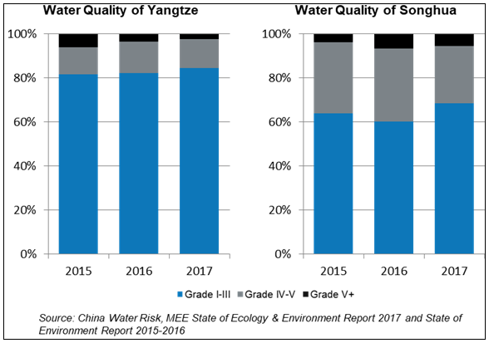
Yellow, Pearl & Huai worsen
- Yellow River – Grade I-III water quality deteriorated from 59.1% to 57.7%. Grade V+ water quality also worsened from 13.9% to 16.1%.
- Pearl River – Grade I-III water quality deteriorated from 89.6% to 87.3%. Grade V+ water quality also slightly worsened from 3.6% to 4.2%.
- Huai River – Grade I-III water quality deteriorated from 53.3% to 46.1%. Grade V+ water quality also slightly worsened from 7.2% to 8.3%.
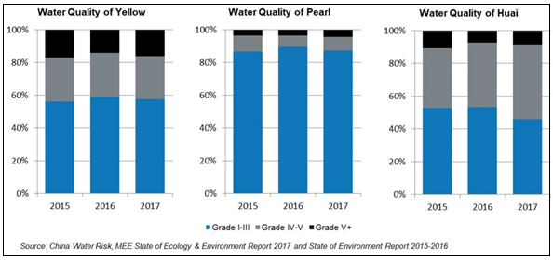
Hai & Liao perform “so-so”
- Hai River – Although being the river with the most Grade V+ water, its proportion of Grade V+ water markedly improved from 41% to 32.9%. Grade I-III water also improved from 37.3% to 41.7%. It is its first time to reverse the trend of “more good water; but also more really bad water” since 2012.
- Liao River – Unlike Hai River, Grade I-III water in Liao River improved from 45.3% to 49% but Grade V+ water deteriorated from 15.1% to 18.9%.
